Cover Page  LOT # 08811 | 11.5X23.5X36 R6  PLENUM RAW/END CAP    WO 147020  LOT 08811  QTY 1
14X20X36 R6  PLENUM BOXED RAW/END CAP  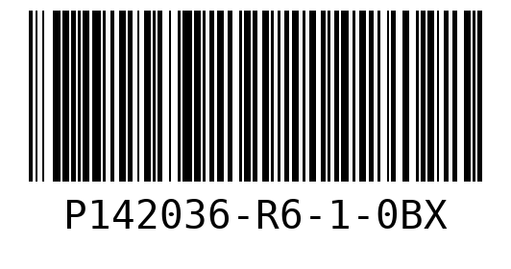  WO 147021  LOT 08811  QTY 10 | 16X20X36 R6  PLENUM RAW/END CAP  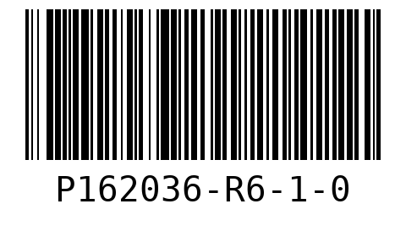  WO 147022  LOT 08811  QTY 20
16X23X36 R6
PLENUM RAW/END CAP
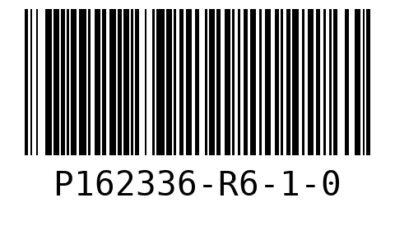
WO 147025
LOT 08811
QTY 10

Sheet # 1  LOT # 08811 | 14X20X36 R6  PLENUM BOXED RAW/END CAP  WO 147021  LOT 08811
14X20X36 R6  PLENUM BOXED RAW/END CAP  WO 147021  LOT 08811 | 14X20X36 R6  PLENUM BOXED RAW/END CAP  WO 147021  LOT 08811
14X20X36 R6  PLENUM BOXED RAW/END CAP  WO 147021  LOT 08811 | 14X20X36 R6  PLENUM BOXED RAW/END CAP  WO 147021  LOT 08811

14X20X36 R6  PLENUM BOXED RAW/END CAP  WO 147021  LOT 08811 | 14X20X36 R6  PLENUM BOXED RAW/END CAP  WO 147021  LOT 08811
14X20X36 R6  PLENUM BOXED RAW/END CAP  WO 147021  LOT 08811 | 14X20X36 R6  PLENUM BOXED RAW/END CAP  WO 147021  LOT 08811
14X20X36 R6  PLENUM BOXED RAW/END CAP  WO 147021  LOT 08811 | 16X20X36 R6  PLENUM RAW/END CAP  WO 147022  LOT 08811

16X20X36 R6  PLENUM RAW/END CAP  WO 147022  LOT 08811 | 16X20X36 R6  PLENUM RAW/END CAP  WO 147022  LOT 08811
16X20X36 R6  PLENUM RAW/END CAP  WO 147022  LOT 08811 | Sheet # 2  LOT # 08811
16X20X36 R6  PLENUM RAW/END CAP  WO 147022  LOT 08811 | 16X20X36 R6  PLENUM RAW/END CAP  WO 147022  LOT 08811

16X20X36 R6  PLENUM RAW/END CAP  WO 147022  LOT 08811 | 16X20X36 R6  PLENUM RAW/END CAP  WO 147022  LOT 08811
16X20X36 R6  PLENUM RAW/END CAP  WO 147022  LOT 08811 | 16X20X36 R6  PLENUM RAW/END CAP  WO 147022  LOT 08811
16X20X36 R6  PLENUM RAW/END CAP  WO 147022  LOT 08811 | 16X20X36 R6  PLENUM RAW/END CAP  WO 147022  LOT 08811

16X23X36 R6  PLENUM RAW/END CAP  WO 147025  LOT 08811 | 16X23X36 R6  PLENUM RAW/END CAP  WO 147025  LOT 08811
16X23X36 R6  PLENUM RAW/END CAP  WO 147025  LOT 08811 | 16X23X36 R6  PLENUM RAW/END CAP  WO 147025  LOT 08811
Sheet # 3  LOT # 08811 | 16X20X36 R6  PLENUM RAW/END CAP  WO 147022  LOT 08811

16X20X36 R6  PLENUM RAW/END CAP  WO 147022  LOT 08811 | 16X20X36 R6  PLENUM RAW/END CAP  WO 147022  LOT 08811
16X20X36 R6  PLENUM RAW/END CAP  WO 147022  LOT 08811 | 16X20X36 R6  PLENUM RAW/END CAP  WO 147022  LOT 08811
16X20X36 R6  PLENUM RAW/END CAP  WO 147022  LOT 08811 | 16X20X36 R6  PLENUM RAW/END CAP  WO 147022  LOT 08811

16X20X36 R6  PLENUM RAW/END CAP  WO 147022  LOT 08811 | 16X23X36 R6  PLENUM RAW/END CAP  WO 147025  LOT 08811
16X23X36 R6  PLENUM RAW/END CAP  WO 147025  LOT 08811 | 16X23X36 R6  PLENUM RAW/END CAP  WO 147025  LOT 08811
16X23X36 R6  PLENUM RAW/END CAP  WO 147025  LOT 08811 | Sheet # 4  LOT # 08811

11.5X23.5X36 R6  PLENUM RAW/END CAP  WO 147020  LOT 08811 | 16X23X36 R6  PLENUM RAW/END CAP  WO 147025  LOT 08811
16X23X36 R6
PLENUM RAW/END CAP
WO 147025
LOT 08811

